**DAY-2 LAB PROGRAMS**

S.Kangana Sri

192210006

CSA1760-Artificial Intelligence

**13. MIN AND MAX ALGORITHM:**

# Define constants

MAX = 1 # Maximizing player

MIN = -1 # Minimizing player

# Example board representation with 0 = empty, 1 = X, -1 = O

board = [

[0, 1, -1],

[1, 1, 0],

[-1, 0, -1]

]

# Function to evaluate the board state

def evaluate(board):

# Check rows for a win

for row in board:

if row[0] == row[1] == row[2] and row[0] != 0:

return row[0]

# Check columns for a win

for col in range(3):

if board[0][col] == board[1][col] == board[2][col] and board[0][col] != 0:

return board[0][col]

# Check diagonals for a win

if board[0][0] == board[1][1] == board[2][2] and board[0][0] != 0:

return board[0][0]

if board[0][2] == board[1][1] == board[2][0] and board[0][2] != 0:

return board[0][2]

return 0 # No winner (draw or ongoing game)

# Check if there are moves left on the board

def is_moves_left(board):

for row in board:

if 0 in row:

return True

return False

# Minimax function

def minimax(board, depth, is_max):

score = evaluate(board)

# If maximizer (X) has won

if score == MAX:

return score - depth

# If minimizer (O) has won

if score == MIN:

return score + depth

# If no moves left, it's a draw

if not is_moves_left(board):

return 0

# Maximizing player's move

if is_max:

best = -float('inf')

for i in range(3):

for j in range(3):

if board[i][j] == 0:

board[i][j] = MAX

best = max(best, minimax(board, depth + 1, not is_max))

board[i][j] = 0

return best

# Minimizing player's move

else:

best = float('inf')

for i in range(3):

for j in range(3):

if board[i][j] == 0:

board[i][j] = MIN

best = min(best, minimax(board, depth + 1, not is_max))

board[i][j] = 0

return best

# Function to find the best move for the maximizing player

def find_best_move(board):

best_val = -float('inf')

best_move = (-1, -1)

for i in range(3):

for j in range(3):

if board[i][j] == 0:

board[i][j] = MAX

move_val = minimax(board, 0, False)

board[i][j] = 0

if move_val > best_val:

best_move = (i, j)

best_val = move_val

return best_move

# Find and print the best move

best_move = find_best_move(board)

print(f"The best move is at position: {best_move}")

**OUTPUT:**



**14. ALPHA BETA PRUNNING:**

import math

def alpha_beta_pruning(depth, node_index, maximizing_player, values, alpha, beta):

if depth == math.log2(len(values)):

return values[node_index]

if maximizing_player:

max_eval = -math.inf

for i in range(2):

eval = alpha_beta_pruning(depth + 1, node_index * 2 + i, False, values, alpha, beta)

max_eval = max(max_eval, eval)

alpha = max(alpha, eval)

if beta <= alpha:

break

return max_eval

else:

min_eval = math.inf

for i in range(2):

eval = alpha_beta_pruning(depth + 1, node_index * 2 + i, True, values, alpha, beta)

min_eval = min(min_eval, eval)

beta = min(beta, eval)

if beta <= alpha:

break

return min_eval

values = [3, 5, 6, 9, 1, 2, 0, -1]

alpha = -math.inf

beta = math.inf

optimal_value = alpha_beta_pruning(0, 0, True, values, alpha, beta)

print("The optimal value is:", optimal_value)

**OUTPUT:**

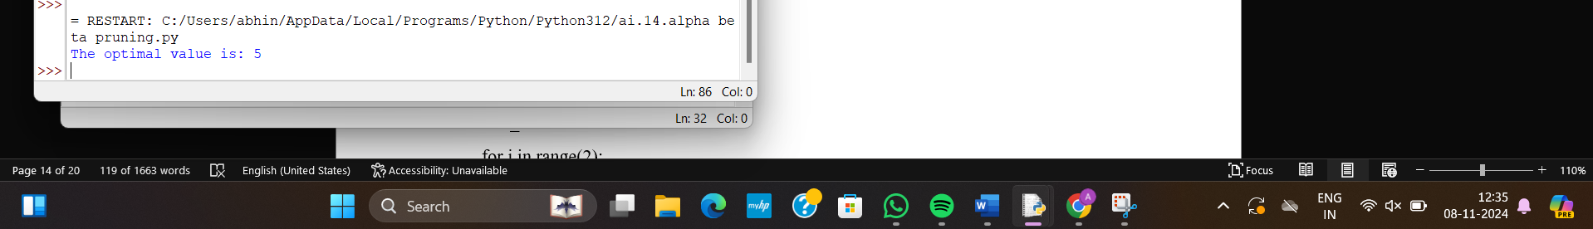

**15. DECISION TREE:**

import math

from collections import Counter

def entropy(labels):

total_count = len(labels)

label_counts = Counter(labels)

entropy_value = 0.0

for count in label_counts.values():

probability = count / total_count

entropy_value -= probability * math.log2(probability)

return entropy_value

def information_gain(data, labels, feature_index):

original_entropy = entropy(labels)

total_count = len(labels)

feature_values = [row[feature_index] for row in data]

value_counts = Counter(feature_values)

weighted_entropy = 0.0

for value, count in value_counts.items():

subset_labels = [labels[i] for i in range(total_count) if data[i][feature_index] == value]

weighted_entropy += (count / total_count) * entropy(subset_labels)

return original_entropy - weighted_entropy

def build_tree(data, labels, features, depth=0):

if len(set(labels)) == 1:

return labels[0]

if len(features) == 0:

return Counter(labels).most_common(1)[0][0]

gains = [information_gain(data, labels, i) for i in range(len(features))]

best_feature_index = gains.index(max(gains))

tree = {features[best_feature_index]: {}}

unique_values = set(row[best_feature_index] for row in data)

for value in unique_values:

subset_data = [row[:best_feature_index] + row[best_feature_index + 1:] for row in data if

row[best_feature_index] == value]

subset_labels = [labels[i] for i in range(len(data)) if data[i][best_feature_index] == value]

new_features = features[:best_feature_index] + features[best_feature_index + 1:]

subtree = build_tree(subset_data, subset_labels, new_features, depth + 1)

tree[features[best_feature_index]][value] = subtree

return tree

def predict(tree, sample):

if not isinstance(tree, dict):

return tree

feature = next(iter(tree))

feature_value = sample.get(feature)

if feature_value in tree[feature]:

return predict(tree[feature][feature_value], sample)

else:

return None

data = [

[1, 0], [1, 1], [0, 0], [0, 1], [0, 0]

]

labels = [0, 1, 0, 1, 0]

features = ['Feature 1', 'Feature 2']

decision_tree = build_tree(data, labels, features)

print("Decision Tree:")

print(decision_tree)

sample = {'Feature 1': 0, 'Feature 2': 1}

print("\nPrediction for sample {}: {}".format(sample, predict(decision_tree, sample)))

**OUTPUT:**

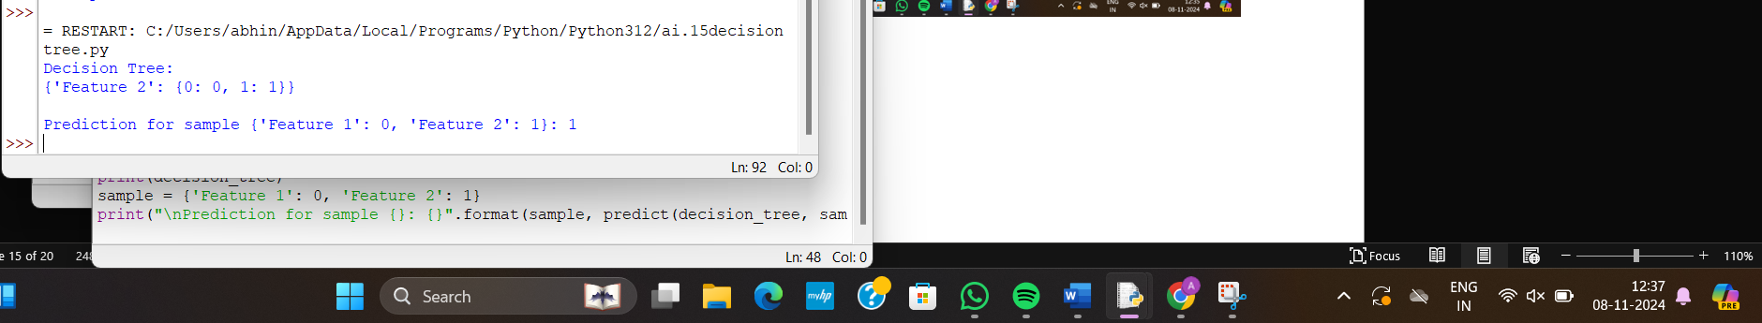

**16. FORWARD NEURAL NETWORK:**

import math

import random

def sigmoid(x):

return 1 / (1 + math.exp(-x))

class NeuralNetwork:

def __init__(self, input_size, hidden_size, output_size):

self.input_size = input_size

self.hidden_size = hidden_size

self.output_size = output_size

self.weights_input_hidden = []

for _ in range(self.input_size):

self.weights_input_hidden.append([random.uniform(-1, 1) for _ in range(self.hidden_size)])

self.bias_hidden = [random.uniform(-1, 1) for _ in range(self.hidden_size)]

self.weights_hidden_output = []

for _ in range(self.hidden_size):

self.weights_hidden_output.append([random.uniform(-1, 1) for _ in range(self.output_size)])

self.bias_output = [random.uniform(-1, 1) for _ in range(self.output_size)]

def feedforward(self, inputs):

hidden_sum = []

for j in range(self.hidden_size):

neuron_sum = 0

for i in range(self.input_size):

neuron_sum += inputs[i] * self.weights_input_hidden[i][j]

neuron_sum += self.bias_hidden[j]

hidden_sum.append(neuron_sum)

hidden_output = [sigmoid(x) for x in hidden_sum]

output_sum = []

for k in range(self.output_size):

neuron_sum = 0

for j in range(self.hidden_size):

neuron_sum += hidden_output[j] * self.weights_hidden_output[j][k]

neuron_sum += self.bias_output[k]

output_sum.append(neuron_sum)

final_output = [sigmoid(x) for x in output_sum]

return final_output

if __name__ == "__main__":

nn = NeuralNetwork(input_size=2, hidden_size=3, output_size=1)

input_data = [0.7, 0.3]

output = nn.feedforward(input_data)

print("Input:", input_data)

print("Output:", output)

**OUTPUT:**

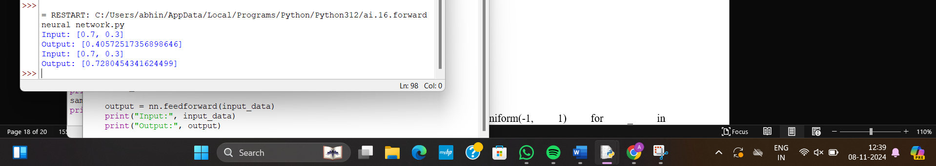

**Sum of Integer 1 to n:**

% Base case: The sum of integers from 1 to 0 is 0.

sum_to_n(0, 0) :-

write('Base case reached: sum from 1 to 0 is 0.'), nl.

% Recursive case: The sum of integers from 1 to N is N plus the sum from 1 to (N-1).

sum_to_n(N, Sum) :-

N > 0, % Ensure N is greater than 0.

N1 is N - 1, % Calculate N-1.

sum_to_n(N1, Sum1), % Recursively calculate the sum of integers from 1 to N-1.

Sum is Sum1 + N, % Add N to the sum of integers from 1 to N-1.

write('Summing: 1 + 2 + ... + '), write(N), write(' = '), write(Sum), nl.

% Main entry point to call the sum and print the result

print_sum(N) :-

sum_to_n(N, Sum),

write('Total sum from 1 to '), write(N), write(' is: '), write(Sum), nl.

**Output:**

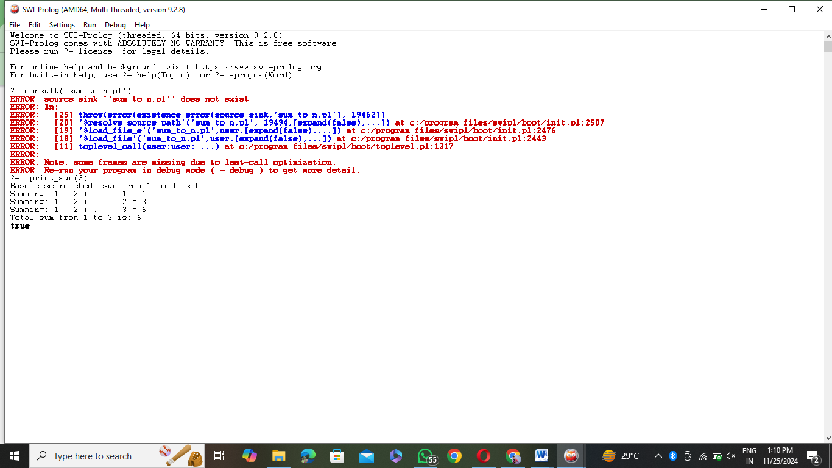

**DB With name:**

% Facts: Name, Age, Gender

person('Alice', 25, female).

person('Bob', 30, male).

person('Charlie', 22, male).

person('Diana', 27, female).

% Query a person by name

find_person(Name, Age, Gender) :-

person(Name, Age, Gender),

write('Name: '), write(Name), nl,

write('Age: '), write(Age), nl,

write('Gender: '), write(Gender), nl.

% Add a new person to the database

add_person(Name, Age, Gender) :-

assertz(person(Name, Age, Gender)),

write('Person added: '), write(Name), nl.

% Remove a person from the database

delete_person(Name) :-

retract(person(Name, _, _)),

write('Person removed: '), write(Name), nl.

delete_person(Name) :-

write('No person found with name: '), write(Name), nl.

% List all people in the database

list_people :-

person(Name, Age, Gender),

write('Name: '), write(Name), write(', Age: '), write(Age), write(', Gender: '), write(Gender), nl,

fail.

list_people :- write('End of list.'), nl.

**Output:**